The analysis of the photo of SC reentry on the Tahiti Island
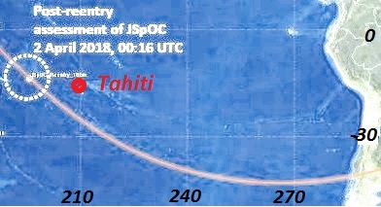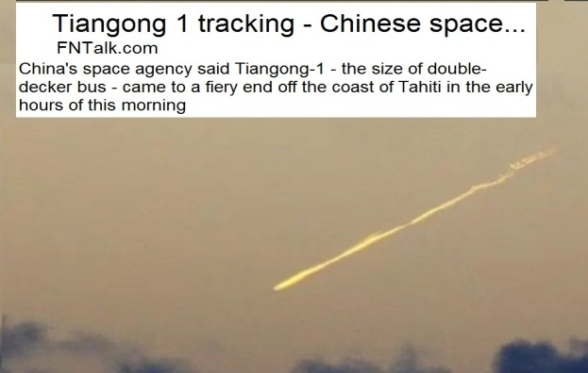
These drawings were provided in the text of the report [1] and the publication [2]. However there were doubts whether this photo of SC reentry is valid. The Tahiti Island is located quite far from the route of flight of SC before his reentry. For elimination of doubts the following operations were executed:
- The route of SC reentry on time interval in the neighborhood of the reference reentry point at 0 hours 16 minutes on April 2, 2018 is built.
- Coordinates of SC of rather possible observer on the Tahiti Island are calculated (longitude 210.0 °, latitude -14.7 °).
For performance of the first operation the “OFM_2018.pas” program of the section "Cases 2018\IKI Seminar\OFM_April" was used. Parameters of the program were corrected. Namely, values were accepted: nz=12, Cj=0.25, val_Sb [1.3]: =Sb. For these parameters estimated time of achievement of altitude of 80 km made 0h: 20m (table1). At the forecast assessment of ballistic coefficient of Sb=0.00278 kg/sq.m was used.
Table 1. Orbital data of SC reentry on April 2
Time, h,m | h, km | Long ° | Lat ° | d, km | El ° | Az °
0h:10.6 | 95.85 | 195.25 | -12.82
0h:11.1 | 95.27 | 196.74 | -14.18 | 1333 | -1.87 | 271.0
0h:11.6 | 94.67 | 198.25 | -15.54 | 1169 | -0.58 | 264.0
0h:12.1 | 94.04 | 199.78 | -16.88 | 1027 | 0.67 | 255.0
0h:12.6 | 93.38 | 201.34 | -18.20 | 916 | 1.77 | 243.5
0h:13.1 | 92.69 | 202.92 | -19.52 | 850 | 2.47 | 229.5
0h:13.6 | 91.97 | 204.53 | -20.81 | 839 | 2.56 | 214.2
0h:14.1 | 91.21 | 206.17 | -22.09 | 885 | 1.97 | 199.5
0h:14.6 | 90.42 | 207.85 | -23.35 | 980 | 0.92 | 187.0
0h:15.1 | 89.60 | 209.55 | -24.59 | 1112 | -0.35 | 177.1
0h:15.6 | 88.73 | 211.30 | -25.81 | 1269 | -1.67 | 169.4
0h:16.1 | 87.83 | 213.08 | -27.00
0h:16.6 | 86.89 | 214.90 | -28.17
0h:17.1 | 85.90 | 216.77 | -29.30
0h:17.6 | 84.87 | 218.67 | -30.41
0h:18.1 | 83.79 | 220.63 | -31.49
0h:18.6 | 82.67 | 222.63 | -32.53
0h:19.1 | 81.49 | 224.69 | -33.53
0h:19.6 | 80.25 | 226.79 | -34.49
0h:20.1 | 79.82 | 227.50 | -34.81

The corresponding fragment of the output file to which three columns with estimates of range (d), an elevation (El) and an azimuth (Az) of SC of the observer on the Tahiti Island are added on the right is given in table 1. These estimates are highlighted in bold type. In figure 1 schemes of calculation of coordinates of SC concerning the observer are submitted.
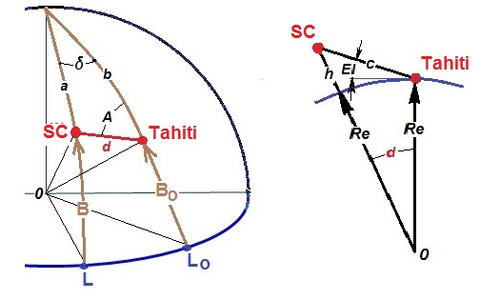
Figure 1. Schemes of calculation. (h – altitude, L - longitude, B - latitude)
Formulas for calculation of coordinates
,
,
,
,
,
.
These formulas were realized in the “my photo new.pas” program. Basic data for calculation were read out from the output file of the previous program (table 1). Results are written down in the “elev_t.new” file and then in table 1.
Data on the announced point of SC reentry are highlighted with red color in table 1 according to NORAD (0h: 11m). This time was 5 minutes less than the announced time [3] flights of SC through this point (0h: 16m). Estimated time of achievement of height of 80 km made 0h: 20m.
The following important conclusions follow from data of table 1:
- On April 2, 2018 in 0h: 11m the SC flew by through the reentry point announced by NORAD (longitude 195.7 °, latitude -13.6 °) at the altitude of 95 km. Aerodynamic loadings and heating of structural elements lead at this height to destruction of KA.
- 1 minute later in 0h: 12m the SC appeared over the horizon in a visibility range of the observer on the Tahiti Island at the range of ≈1000 km.
- Within 3 minutes (to 0h: 15m) the SC was in a visibility range of the observer. At the maximum elevation of El =2.56 ° the minimum range to SC was 839 km.
- The direction azimuth on SC changed in a visibility range from 260 ° (≈on the West) up to 180 ° (on the South).
- According to the forecast, in the time point of reentry announced by NORAD (0h: 16m) the SC was at the altitude of 88 km and already left a visibility range of the observer on the Tahiti Island.
Placement of the results stated above in the picture of SC reentry taken by the observer on the Tahiti Island is very tempting. However when performing this operation certain difficulties there are. They are caused by absence on a photo of a coordinate grid and tags of time. Three assumptions were made for overcoming these difficulties:
- As the first assessment for placement on graphics time point 0h13:6m is chosen: to which there corresponds the maximum elevation.
- As the last assessment time point 0h15:6m is chosen: to which there corresponds the minimum elevation.
- Due to a possibility of arrangement of the observer on the mountain, the scale of values of an elevation is chosen in the range from -2.6 ° up to 3.8 °.
The corresponding results of placement of design data on a photo are presented in figure 2.
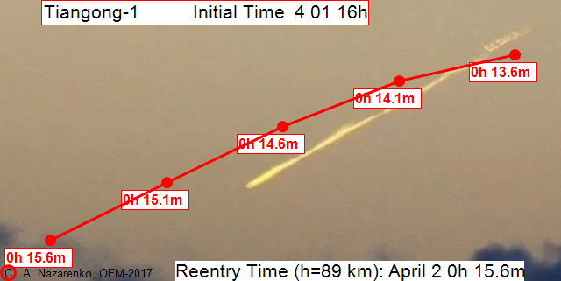
Figure 2. Estimate charts of SC flight through a visibility range of the observer
The acceptable consent of the settlement and real reentry trajectory allows drawing the conclusion that in the photo the Tiangong 1 reentry is really presented.
From data of figure 2 it is visible that real decrease in SC under the influence of the atmospheric drag happened more intensively in comparison with estimated results. It can be explained with increase in ballistic coefficients of fragments of SC destruction. As a result, in comparison with projections, real time of SC reentry came.
Comment
In the materials stated above there is an essential disagreement of the published yielded and estimated results. Namely, posteriori assessment of NORAD of time 0h: 16m of flight of SC through a point of "reentry" (longitude 195.7 °, latitude -13.6 °) is 5 minutes more than estimated time of flight through this point. At the same time on design data (table 1, figure 2) at the altitude of ≈88 km SC left a visibility range of the observer on the Tahiti Island in time point 0h: 16m. How to explain this disagreement?
Data from the Internet on the SBIRS system of the USA are given [4] below.
For fixing of the fact of start of ballistic missiles from the territory of the countries having rocket technologies, and timely reduction of a missile defense system in combat readiness in the USA the program of observation of the land surface based on spacecrafts of new generation is implemented. Works on creation of the SBIRS system (Space-Based Infrared System is the Infrared system of space basing) began still in the mid-nineties. Implementation of the program had to come to the end in 2010. The first SBIRS-GEO, GEO-1 satellite began work in 2011. As of 2015 only two geostationary satellites and two satellites of the top echelon in elliptic orbits were brought to an orbit.
If to assume that the data on time and the place of SC reentry announced by NORAD are result of work of the USA SBIRS, then the mentioned disagreement is explained by features of the technology applied by them. Namely, in time point 0h: 11m in the announced point of "reentry" (longitude 195.7 °, latitude -13.6 °) the torch formed at an entrance of SC to dense beds of the atmosphere was found. Then within several minutes this torch was observed by the infrared telescope. Approximately in 0h: 16m the torch dropped out of a field of telescope, and this time was announced as time of SC reentry.
Thus, a posteriori data of NORAD belong to different time points: coordinates – by the time of detection of a torch, and time – by the time of the SC reentry. The disagreement mentioned above is explained by it.
Conclusions
- The acceptable consent of the settlement and real reentry trajectory allows drawing the conclusion that SC Tiangong 1 reentry is really presented in the photo.
- A posteriori data of NORAD belong to different time points: coordinates – by the time of detection of a torch, and time – by the time of the SC reentry.
References
- А.I. Nazarenko, I.V. Usovik. The effect of parameters of the initial data updating algorithmт on the accuracy of spacecraft reentry time prediction. Fifth IAA Symposium “Space Flight Safety-2018”, St._Peterburg, Journal of Space Safety Engineering, 2019, in printing.
- А.I. Nazarenko. Stochastic astrodynamics problems. Mathematical methods and solving algorithms, Section 20, Examples of reentry determination. Cambridge Scholars Publishing, 2019, in printing.
- http://www.space-track.org.
- https://topwar.ru/92958-sistema-pro-ssha-chast-2-ya.html

